Volume XVII, Number 3, September, 2013
Our Next Event is…  The Fall Technical Meeting  Thursday, September 26th,2013  White Pines Golf Club and Banquets  500 West Jefferson Ave.  Bensenville, IL 60106  630-766-0304  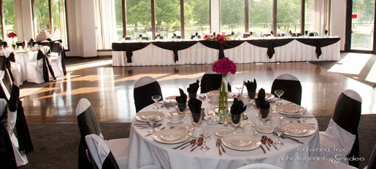  Check-in: 3:30 PM -- 4:00 PM  Presentation: 4:00 PM -- 5:00 PM  Cocktails: 5:00 PM -- 6:00 PM  Dinner: 6:00 PM  Technical Presentation  Ernie Perez, Global Deployment Manager, Six Sigma ICR, SKF Sealing Solutions  "Optimizing Six Sigma for Your Business"  Please visit our website for the most up-to-date information at:  http://www.chicagorubbergroup.org  In This Issue of the Newsletter…  - Donations  - CRG Election – Secretary Candidates Needed!  - Scholarship Update  - 2014 Rubber Course Preview  - Newsletter Advertisement  - Rubber Division ACS Update  - Membership and Renewal  - Golf Outing Recap | President’s Message  I hope everyone had a safe Summer Season! As fall approaches, I wish to thank the Chicago Rubber Group Executive Board and our membership for another successful year! Attendance was good at the technical meetings, but always could be better, so please be sure to do your part and come help give our speakers a good audience. I also wish to thank Mike Szymborski, Mike Collins and the Golf Outing Committee for their outstanding efforts in organizing the Chicago Rubber Group Golf Outings. Outings both at Indian Lakes and Hawk’s View were held, but were down in attendance from last year. Yet and still, for those of you that did attend, thank you for your continued support. These events primarily help support our Rubber Group’s scholarship and educational programs.  I would like to remind everyone that the 179th RDACS Rubber Expo and Technical Meeting will be held this October 7th to 10th at the I-X Center, Cleveland, Ohio. Please visit their website at www.rubber.org for further information and registration. Included in this RDACS event will be a Job Fair on Thursday, October 10 between 10:00 am and 2:00 pm. If you are interested in volunteering and helping at this event, please contact Tim Day at tim@chemrep.com.  The Fall Technical Meeting will be held on Thursday, September 26 at the White Pines Golf Course, Bensenville, Illinois. The Technical Speaker is Mr. Ernie Perez, Global Deployment Manager, Six Sigma ICR, SKF Sealing Solutions – “Optimizing Six Sigma for Your Business”. Presentation details and Bio are on the website.  I would also like to extend a thank you to Mark Hlinak for his outstanding work on keeping our website and newsletter up to date!  Finally, I wish to thank the Board Members for their participation. Volunteers are always welcomed and we in fact still need Secretary Candidates for the 2014 board election that still needs to be held, so if you would like to become part of this outstanding organization, please contact me at milton2208@aol.com, or Mike Amis at mamis@apimix.net to get on the ballot.  Your contributions are sincerely appreciated. I hope to see you all at the Technical Meeting on September 26th.  Howard Robins, President,  The Chicago Rubber Group, Inc.  Reserve your spot for dinner at the technical meeting here:  http://www.chicagorubbergroup.org/tech_meeting_reservation_form.pdf | President  Howard Robins  Vice President  Michelle Rodriguez  SKF Aerospace  Treasurer  Jessica Petras  Chem Rep  Secretary, Editor and Webmaster  Mark Hlinak  RotaDyne  Past President  Mike Amis  American Phoenix  Rubber Division Area Director  Leonard Thomas  Manufacturer Directors  Rick Davies  Preferred Rubber  Deidre Tucker  SKF Sealing Solutions  Supplier Directors  Mark Guzzaldo  Harwick Standard Distribution  Tim Peterschmidt  Barton Solvents  Scholarship Chair  Richard Alt  Membership Chair  Paul Stoeck  Trostel Ltd.  Parliamentarian /  Registered Agent  Linda Kapsa -- Retired  Historian / Education Chair  Ron Coia – Retired  Necrology  Paul Miller – Retired  Golf Outing Chairs  Mike Szymborski  Trostel Ltd.  Mike Collins  Barton Solvents

Special Thanks to Our Donors!  The Chicago Rubber Group would like to thank the companies and individuals that have contributed to our group in 2013, especially those who chose to give a $300 annual donation. Annual donations account for:  - $150 for the CRG Chicago Golf Outing and  - $75 each for the Spring and Fall Technical Meetings  Donations help to fund our scholarships, technical meetings, and other interesting programs. To see how else the CRG puts your donations to work, go to our Donations page:  http://www.chicagorubbergroup.org/donations.htm  Please forward Individual Fall Technical Meeting Donations in the suggested amount of $75 to:  Jessica Petras  CRG Treasurer  Chem Rep  1728 West Barry #3  Chicago, IL 60657  …Or make your donation online using a major credit card from our Payments Page:  http://www.chicagorubbergroup.org/payments.htm  CRG Election 2014 – Secretary Candidates Needed!  CRG Board Elections are held in the fall to finalize the seats for our Executive Board the following year. The CRG is looking for volunteers to fill the seat of Secretary for the 2014 Executive Board. Anyone interested in becoming CRG Secretary, or if you know of a qualified person to become Secretary, please contact Past President Mike Amis at mamis@apimix.net, or one of our other officers. To preview duties and responsibilities of the Secretary, they can be found on page 6 of our Constitution and Bylaws:  http://www.chicagorubbergroup.org/CRG_Constitution_and_Bylaws_10-23-2012.pdf  Scholarship Update  The CRG is now accepting applications for the 2014 Harold Stark Memorial Scholarship and nominations for the 2014 Robert Kann Educational Award. The Stark Scholarship is $1000 awarded annually for four years to a deserving graduating high school senior with the highest ACT test score. The Kann Award is $1000 awarded to someone who is already working in the rubber industry nominated by his or her peers to defray the cost of ongoing training or continuing education. 2014 will also see the return of the Boris N. Dinzburg Education Award, which is a $375 reimbursement of course fees at the upcoming Spring Basics of Rubber Technology Course.  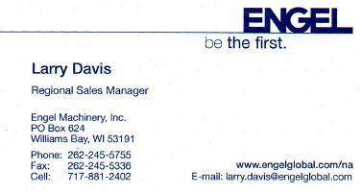 | Scholarship Update (cont’d)…  In 2013, the Stark winner was Joseph May who attended High School at York Community High School in Elmhurst, IL. He is now or shortly will be entering college at Grand Valley State University in Allendale, MI. The winner of the 2013 Kann Award was Jim Krough from MC Products. Special thanks to his coworker Kathy Hurka for nominating Jim. Please click below to go to our Scholarship Page to find out more about the winners and our scholarship programs:  http://www.chicagorubbergroup.org/scholarships.htm  2014 Basics of Rubber Technology Course  The CRG’s 2014 Basics of Rubber Technology Course is expected to be held at SKF Sealing Solutions in Elgin, IL from March 18th through the 20th of 2014. This course is held every two years by the CRG, and we are looking forward to another successful session in 2014. The CRG Education Committee met in April of 2013 to begin preliminary planning for this course and will meet again in October to begin gathering the slate of speakers and instructors for the course.  2014 will mark the second awarding of the Boris N. Dinzburg Educational Award, which amounts to reimbursement of course sign-up fees to one student attending the course – a $375 value. Watch for more about the course and how to sign up in the winter 2013 newsletter. To read more about the course, go to our Rubber Course Page:  http://www.chicagorubbergroup.org/rubber_course.htm  Renew or Begin your Newsletter Advertisement  Further help our group by placing your business card-sized advertisement in this newsletter, and on our website. Begin or renew your advertisement for 2014 now! Your newsletter advertisement helps pay for the cost of distribution of the newsletter as well as maintenance and up-keep of the CRG’s website. Click below to download the signup form.  http://www.chicagorubbergroup.org/newsletter_ad_form.pdf  Rubber Division ACS Update  The 184th ACS Rubber Division Technical Meeting and symposium will take place from October 7th through the 10th, 2013 at the I-X Center in Cleveland, OH. This International Elastomer Conference will feature the Division’s International Rubber and Advanced Materials in Healthcare Expo. Please click one of the links below to see the latest on this event, as well as the CRG’s Area Director’s report and other goings on at the Rubber Division ACS.  http://www.chicagorubbergroup.org/RDACS.htm and  http://www.rubber.org  Joining Our Group and Renewing Your Membership  Help support the CRG by paying your dues! If you haven't already for 2013, join or renew your membership today by visiting our Membership Page. 2014 dues are also being accepted. The deadline to sign up or renew for 2014 is January 31st, 2013:  http://www.chicagorubbergroup.org/membership.htm

2013 CRG Chicago Golf Outing Summary  The Chicago Rubber Group would like to thank the companies and individuals that participated and contributed to our CRG Chicago Golf Outing this year at Indian Lakes in Bloomingdale, IL. Here is a list of the companies that donated to this outing:  This outing was held at Hilton Indian Lakes on Thursday, July 18th. Although it was a hot day, there was breeze that made it comfortable. We even had a surprise shower spring up late in the round that was refreshing.  Disappointingly, attendance continues to decline year after year. This year we had 76 for golf and 75 for dinner. Last year we had 92 for golf and 83 for dinner. If you attended the event and had a good time, make sure you tell your friends and coworkers, and make sure you come again next year.  The event was successful in that we raised over $5,000 in donations that will go towards funding the Scholarships offered by the CRG. I think everybody would agree that dinner was excellent, and there were many great prizes given away on the raffle table.  During in informal show of hands at dinner, it was agreed to make next year’s event a “best ball scramble”. This should speed the pace of play, and possibly encourage less serious golfers to come out to our event.  Mark your calendars next year for Thursday, July 17th. We appreciate the support of all of our corporate sponsors and participants and look forward to seeing you all out there again in 2014.  Mike Szymborski  CRG Chicago Golf Chair | 2013 CRG Wisconsin Golf Outing Summary  Special thanks also to the companies that donated to the CRG Wisconsin Golf Outing held on Wednesday, August 14th at Hawks View in Lake Geneva, WI!  Lavelle Industries  Dow Automotive  Barton Solvents, Inc.  ChemRep, Inc.  Akrochem  Preferred Compounding  Hallstar  Harwick  Dynamic Rubber  Polymer Valley Chemicals, Inc.  Struktol Company of America  American Roller Company  This outing was attended by 42 golfers. The format was actually changed this year to a four person best ball scramble. Yet and still, this outing also continues to see a decline in participation. Mike Szymborski’s comments to the left also hold true for this outing – if you attended and had a good time, tell your friends and coworkers and try to get them to join you next year! The golf outings are our main source of revenue for our scholarship programs, which are after all, the primary focus of our rubber group!  Mike Collins  CRG Wisconsin Golf Chair  For more information on our annual golf outings, go to our golf outings page:  http://www.chicagorubbergroup.org/golf_outings.htm  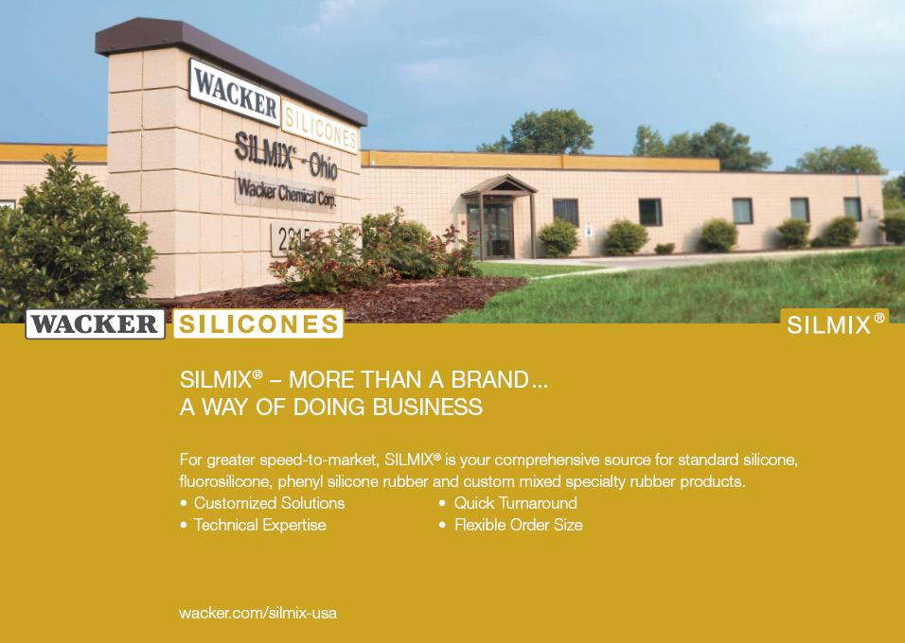
  3M  AB Chemical  Akzo Nobel  Akrochem  American Phoenix  Asbury Graphite  Barton Solvents  Cabot  Cancarb  Calumet Rubber  Chem Rep  Chem Spec.  Daikin Americas  Flow Polymers  Hallstar  Harwick Standard Dist. | Polyonics  Portage Precision Polymers  Rahco Rubber  Rep  RT Vanderbilt  Sid Richardson  Solvay Solexis  Sovereign Chemical  Stemaco  Struktol  TL Squire  Trostel, Ltd.  TSE  US Zinc  Valhalla  Wacker Silicones  Zeon Chemicals
Click Here for Directions to the Technical Meeting at White Pines → http://www.whitepinesgolf.com/contact-us.html

