Volume XVI, Number 2, May, 2012
Chicago Rubber Group Technical Meeting  Tuesday, May 15th  at  Grand Geneva Resort of Lake Geneva  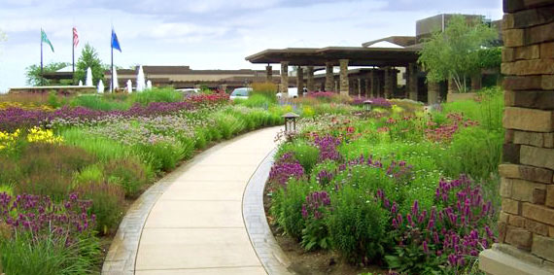  7036 Grand Geneva Way (Hwy 50)  Lake Geneva, WI 53147  800-558-3417  Registration 3:00  Program 3:30 PM  Social Hour 5:30 PM  Dinner 6:15 PM  Guest Speakers:  Steven Lois, Edward Jones  "Economic Outlook for Manufacturing, the Markets, and the Pace of Recovery"  George W. Shepherd, III,  Infineum USA L.P.  "Infineum Trends: Developments in the Oil, Automotive, and Additives Industries"  To Make Dinner Reservations and More, Visit Our Website:  http://www.chicagorubbergroup.org  In This Issue of the Newsletter…  - Technical Meeting Announcement  - President’s Message  - Donation Appeal  - Rubber Division ACS Report  - Membership and Renewal  - Scholarship and Education Awards Update  - 2012 Basics of Rubber Technology Course Summary  - Golf Outing Announcements  - Newsletter Advertisements Reminder | President’s Message  Hello everyone, and welcome to the Chicago Rubber Group’s 2012 Spring Technical Meeting!  I want to take this opportunity to tell you all how honored I am to serve as your president. This is a wonderful group of people, everyone is good at networking information and it is a great way to learn and keep abreast of our ever-changing industry.  To some, springtime means gardening, landscaping and getting the birdfeeders cleaned out. But to those of us here at the Chicago Runner Group, it means GOLF!  This year we have TWO! The first is Thursday, July 19th at the Hilton’s Indian Lakes Resort, Bloomingdale, IL. The second one will be out in Wisconsin Wednesday, August 15th - Hawk's View Golf Club, Lake Geneva, WI.  You don’t have to write that down right now - it is on the website – and it is always a good idea to check the website frequently to check up on all the happenings at the Chicago Rubber Group. If you see Mark Hlinak around – send him your appreciation for all his work on our website. It is always up to date, and looks very nice – Thanks Mark.  So, keep in mind, we are looking for sponsors, and prize donations for the outings.  At this time I would also like to welcome new board members, and new members to the Chicago Rubber Group! We welcome your input, and hope that you learn new things, gain important information and enjoy the networking that the Chicago Rubber Group can provide. I look forward to a productive year, and the continued dedication to learning and advancing our knowledge base and innovation in the rubber industry.  And finally, a big thank you goes out to all the board members, past and present, as well as all of the volunteers who make everything from the newsletter to the meetings, to scheduling speakers, to the outings possible. In many ways, what the CRG does reminds me of a (politically corrected) quote from Theodore Roosevelt: “Every man [or woman] owes some of his [or her] time to the up-building of the profession to which he [or she] belongs.”  Mike Amis  CRG, President | President  Mike Amis  American Phoenix, Inc.  Vice President  Howard Robins  Treasurer  Michelle Rodriguez  SKF Aerospace  Secretary  Jessica Petras  Chem Rep  Past President and Scholarship Chair  Richard Alt  Acme Machell  Rubber Division Area Director  Leonard Thomas  Manufacturer Directors  Rick Davies  Preferred Rubber  Mark Hlinak  RotaDyne  Supplier Directors  Mark Guzzaldo  Harwick Standard Distribution  Tim Peterschmidt  Barton Solvents  Editor / Webmaster  Mark Hlinak  RotaDyne  Membership Chair  Paul Stoeck  Trostel Ltd.  Parliamentarian /  Registered Agent  Linda Kapsa -- Retired  Historian / Education Chair  Ron Coia – Retired  Necrology  Paul Miller – Retired  Golf Outing Chairs  Mike Szymborski  Trostel Ltd.  Mike Collins  Barton Solvents
  CRG 2012 Remaining Schedule of Events
  Spring Technical Meeting | May 15th, Grand Geneva Resort, Lake Geneva, WI
  CRG Chicago Golf Outing | July 19th, Hilton’s Indian Lakes Resort, Bloomingdale, IL
  CRG Wisconsin Golf Outing | August, 15th Hawks View Golf Club, Lake Geneva, WI
  Fall Technical Meeting | September 20th, The Doubletree, Arlington Heights, IL

2012 Donation Appeal  As was the case in 2011, there was no technical meeting in January, 2012, so consequently there are no meeting donors to report. However, the CRG would like to take this opportunity to remind the membership that it is not too late to donate to the CRG for 2012! Please go to http://www.chicagourbbergroup.org/donations.htm to learn how to donate and what your donation means to not only the CRG, but also to you and your company. In short, the help of both suppliers and manufacturers enables us to maintain our scholarships, education awards, the Basics of Rubber Technology course, the Golf Outings, and other interesting programs.  Please forward annual donations for 2012 in the suggested amount of $300 or May Technical Meeting Donations in the suggested amount of $50 to:  Michelle Rodriguez  CRG Treasurer  SKF  900 North State Street  Elgin, IL 60123  …Or make your donation online using a major credit card from our Payments Page:  http://www.chicagorubbergroup.org/payments.htm  Annual donations of $300 account for $150 donation for the CRG Chicago Golf Outing and $50 for each CRG technical session.  Rubber Division ACS Update  Please click one of the links below to see the latest on this event, as well as the CRG’s Area Director’s report and other goings on at the Rubber Division ACS.  http://www.chicagorubbergroup.org/RDACS.htm and  http://www.rubber.org  Joining Our Group and Renewing Your Membership  Help support the CRG with your membership! If you haven't already, join or renew your membership today by visiting our Membership Page:  http://www.chicagorubbergroup.org/membership.htm  Scholarship and Education Awards Update  The CRG would like to congratulate Jason Dolinski who is the winner of the 2012 Harold Stark Memorial Scholarship. Jason attended high school in LaGrange Park, IL and will be entering college in the fall. Congratulations also go out to Nerone Soetaert from Trostel, who is the winner of the Robert Kann Educational Award for 2012, and Kathy Hunter from Ebco who was the recipient of the Boris Dinzburg Award at our Rubber Course in March. Please visit our Scholarship Page to find out more:  http://www.chicagorubbergroup.org/scholarships.htm | 2012 Basics of Rubber Technology Course Summary  As planned, the CRG’s bi-annual Basics of Rubber Technology Course was held at SKF Sealing Solutions in Elgin, IL from March 21st through the 23rd. There were 36 course participants in attendance and some 19 instructors provided the course materials. Also new to this year’s course, as mentioned previously were the first ever social night at Jimmy’s Charhouse in Elgin, IL after the first day of the course and the Boris Dinzburg Education Award in which one of the course participants was randomly selected to receive his or her course tuition free of charge. The lucky winner of that award this year was Kathy Hunter from Ebco. Congratulations Kathy! The CRG Education Committee is to meet on Monday, April 23rd to discuss results of the course and to discuss the student recommendations voiced in the course feedback forms. To read more about our course, click the link below to go to our Rubber Course Page:  http://www.chicagorubbergroup.org/rubber_course.htm  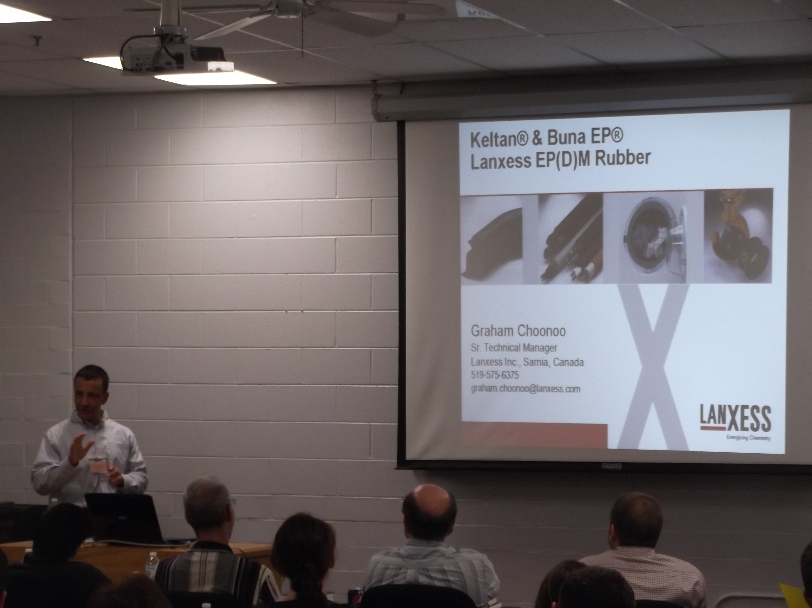  Above: Graham Choonoo of Lanxess Presents EPDM rubber to the CRG Basics of Rubber Technology Course Participants on March 21st, 2012.  2012 CRG Golf Outings  The Chicago Rubber Group is pleased to announce that both the CRG Chicago and the CRG Wisconsin Golf Outings will once again be held in 2012. The CRG Chicago Outing will again be held at Hilton’s Indian Lakes Resort on Thursday, July 19th. The CRG Wisconsin Outing will be held on Wednesday, August 15th, at Hawk’s View Golf Club in Lake Geneva, WI. Please visit our Annual Golf Outings Page for the latest information and to register your foursomes. New for 2012, you will not be able to sign up for the Wisconsin Outing until after the Chicago Outing in July – this is simply to avoid confusion among the Golf Committee for the two outings. If you have any questions regarding the golf outings, please contact Mike Szymborski for the Chicago Outing (mikes@trostel.com), or Mike Collins for the Wisconsin Outing (mikec@barsol.com).  http://www.chicagorubbergroup.org/golf_outings.htm  Newsletter Advertisement Renewal  Regrettably, no companies have yet decided to renew their advertisements in the Chicago Rubber Group Newsletter and website for 2012. Although there is no longer a paper publication, our e-newsletter still reaches many relevant industry professionals in the Chicago area. For the low cost of $100, your business card sized advertisement will be placed in all three newsletters, and on our website’s Sponsors Page for the 2012 calendar year. The website advertisement also includes a URL link to your company’s website. Start your Advertisement today by going clicking the link below:  http://www.chicagorubbergroup.org/newsletter_ad_form.pdf

Northeast Illinois and Southeast Wisconsin and the Location of the Grand Geneva Resort
7036 Highway 50
Lake Geneva, WI 53147
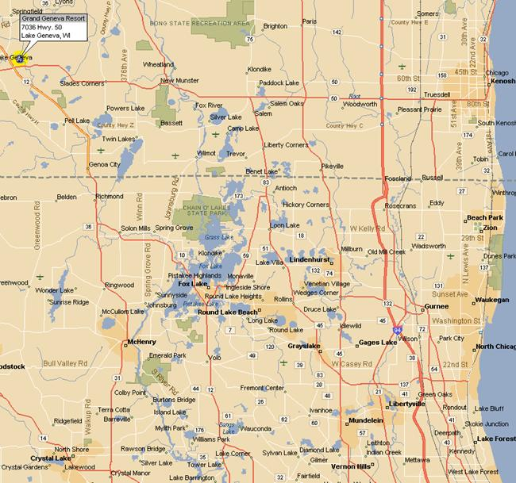

Click Below for Google Map Directions

http://maps.google.com/maps?daddr=7036+Grand+Geneva+Way,+Lake+Geneva,+WI+53147+(Grand+Geneva+Resort+and+Spa)&geocode=CTU1y9tc4l9eFVYtigId-Qq7-iGaryKZwDNw9A&dirflg=&saddr=&f=d&hl=en&dq=Grand+Geneva&sll=42.608064,-88.385954&sspn=0.049779,0.111494&ie=UTF8&ll=42.609801,-88.405244&spn=0.051357,0.111494&z=14

